Stability Analysis at plant Input and Output
Chris Bonney (March 2021)
Program Start 1
Plant Data 1
Dynamics without actuator 2
Dynamics with Actuator 2
Design RSLQR Controllers From HW3 2
Define RSLQG Parameters 2
Design RSLQG Controllers 3
Print Results 4
print controller info for rho = 100 16

Program Start
clear all
close all
clc
format short e
% add my set of functions to path
addpath('functions')
RSLQR.name = 'RSLQR';

Plant Data
Controller Constants
Ka=-0.0015;
Kq=-0.32;
az=2;
aq=6;
% Dynamics Constants
V=886.78;
Za=-1.3046*V;
Zd=-0.2142*V;
Ma=47.7109;
Md=-104.8346;
% Actuator Constants
% omega = sqrt(12769);
% zeta = 0.6;
omega = 2.*pi*11;
zeta = sqrt(1/2);

Dynamics without actuator
Ap = [Za/V 1 ;
Ma 0 ];
Bp = [Zd/V ;
Md ];
Cp = [Za 0 ;
0 1 ];
Dp = [Zd ;
0 ];
RSLQR.DesignPlant = ss(Ap,Bp,Cp,Dp);
% Size of the plant model
[nx,~]=size(Ap);

Dynamics with Actuator
A_actuator = [0 1; -omega^2 -2*zeta*omega];
B_actuator = [0; omega^2];
Plant.Ap = [ Ap Bp zeros(2,1);
zeros(2,2) A_actuator];
Plant.Bp = [zeros(2,1); B_actuator];
Plant.Cp = [Za 0 Zd 0;
eye(4)];
% Plant.Cp = [Za 0 Zd 0;
% 1 0 0 0;
% 0 1 0 0];
Plant.Dp = 0*(Plant.Cp*Plant.Bp);
Ap = Plant.Ap;
Bp = Plant.Bp;
Cp = Plant.Cp;
Dp = Plant.Dp;
RSLQR.AnalysisPlant = ss(Ap,Bp,Cp,Dp);

Design RSLQR Controllers From HW3
RSLQR = design_lqr(RSLQR.DesignPlant,1,[2,3],RSLQR.AnalysisPlant,RSLQR);

Define RSLQG Parameters
Q0 = diag([0.001 0.0014 0.004]);
R0 = 1000*diag([0.025^2 0.001^2]);
rho = [10^10 10^4 10^2];
Aw = RSLQR.Aw;
Bw = RSLQR.Bw;
Kx = RSLQR.Kx;
Cw = [1 0 0;
0 0 1];
for ii=1:length(rho)
RSLQG(ii) = RSLQR;
end

Design RSLQG Controllers
for ii=1:length(rho)
RSLQG(ii).name = strcat('RSLQG, rho=',num2str(rho(ii)));
Qv = Q0 + Bw*Bw'*1/rho(ii);
RSLQG(ii).Qv = Qv;
RSLQG(ii).Rv = R0;
Lrho = lqr(Aw',Cw',Qv,R0)';
RSLQG(ii).Lrho = Lrho;
RSLQG(ii).Lrho
RSLQG(ii).Controller.Ac = [0 zeros(1,3); Lrho(:,1) Aw - Bw*Kx - Lrho*Cw];
RSLQG(ii).Controller.Bc1 = [ 1 0 0 0 0; zeros(3,2) Lrho(:,2) zeros(3,2)];
RSLQG(ii).Controller.Bc2 = [-1;-1; 0; 0];
RSLQG(ii).Controller.Cc = [0 -Kx];
RSLQG(ii).Controller.Dc1 = [0 0 0 0 0];
RSLQG(ii).Controller.Dc2 = [0];
RSLQG(ii) = design_metrics(RSLQG(ii).AnalysisPlant,RSLQG(ii).Controller,RSLQG(ii));
end
ans =
7.7424e+00 -1.8004e+02
-4.8323e-02 1.4016e+00
-2.8807e-01 9.2671e+00
ans =
1.0701e+01 -2.3014e+01
-4.7361e-02 1.4130e+00
-3.6822e-02 3.5171e+01
ans =
1.2979e+01 5.6878e+02
-4.7013e-02 1.7985e+00
9.1005e-01 3.3100e+02

Print Results
print_analysis(RSLQR,RSLQG(1),RSLQG(2),RSLQG(3))
RSLQR Controller Model
[ Ac Bc1 Bc1 ]
HH =
[ 0, 1.0, 0, 0, 0, 0, -1.0]
[ Cc Dc1 Dc2 ]
HH =
[ -0.00954, 0, 2.63, 0.238, 0, 0, 0]
RSLQG, rho=10000000000 Controller Model
[ Ac Bc1 Bc1 ]
HH =
[ 0, 0, 0, 0, 1.0, 0, 0, 0, 0, -1.0]
[ 7.74, -5.93, -1660.0, 135.0, 0, 0, -180.0, 0, 0, -1.0]
[ -0.0483, 0.0504, -1.87, -0.453, 0, 0, 1.4, 0, 0, 0]
[ -0.288, 1.29, -228.0, -34.2, 0, 0, 9.27, 0, 0, 0]
[ Cc Dc1 Dc2 ]
HH =
[ 0, -0.00954, 2.63, 0.238, 0, 0, 0, 0, 0, 0]
RSLQG, rho=10000 Controller Model
[ Ac Bc1 Bc1 ]
HH =
[ 0, 0, 0, 0, 1.0, 0, 0, 0, 0, -1.0]
[ 10.7, -8.89, -1660.0, -22.2, 0, 0, -23.0, 0, 0, -1.0]
[ -0.0474, 0.0494, -1.87, -0.464, 0, 0, 1.41, 0, 0, 0]
[ -0.0368, 1.04, -228.0, -60.1, 0, 0, 35.2, 0, 0, 0]
[ Cc Dc1 Dc2 ]
HH =
[ 0, -0.00954, 2.63, 0.238, 0, 0, 0, 0, 0, 0]
RSLQG, rho=100 Controller Model
[ Ac Bc1 Bc1 ]
HH =
[ 0, 0, 0, 0, 1.0, 0, 0, 0, 0, -1.0]
[ 13.0, -11.2, -1660.0, -614.0, 0, 0, 569.0, 0, 0, -1.0]
[ -0.047, 0.0491, -1.87, -0.85, 0, 0, 1.8, 0, 0, 0]
[ 0.91, 0.0902, -228.0, -356.0, 0, 0, 331.0, 0, 0, 0]
[ Cc Dc1 Dc2 ]
HH =
[ 0, -0.00954, 2.63, 0.238, 0, 0, 0, 0, 0, 0]
RSLQR Closed Loop Eigenvectors
V =
Columns 1 through 2
1.0786e-03 - 5.3831e-04i 1.0786e-03 + 5.3831e-04i
-8.6197e-03 + 5.3792e-02i -8.6197e-03 - 5.3792e-02i
1.4975e-02 + 1.7154e-02i 1.4975e-02 - 1.7154e-02i
-9.9198e-01 + 0.0000e+00i -9.9198e-01 + 0.0000e+00i
1.6200e-02 + 1.1055e-01i 1.6200e-02 - 1.1055e-01i
Columns 3 through 4
-9.2478e-03 + 0.0000e+00i 6.3990e-03 - 6.9127e-03i
2.1023e-01 + 0.0000e+00i -1.2874e-03 + 1.0138e-01i
4.2040e-02 + 0.0000e+00i 9.5275e-03 + 5.9743e-03i
-9.6959e-01 + 0.0000e+00i -1.3059e-01 + 1.0489e-02i
-1.1764e-01 + 0.0000e+00i 9.8607e-01 + 0.0000e+00i
Column 5
6.3990e-03 + 6.9127e-03i
-1.2874e-03 - 1.0138e-01i
9.5275e-03 - 5.9743e-03i
-1.3059e-01 - 1.0489e-02i
9.8607e-01 + 0.0000e+00i
RSLQR Closed Loop Eigenvalues
ans =
-2.8650e+01 + 3.2818e+01i
-2.8650e+01 - 3.2818e+01i
-2.3063e+01 + 0.0000e+00i
-9.3428e+00 + 6.9594e+00i
-9.3428e+00 - 6.9594e+00i
RSLQG, rho=10000000000 Closed Loop Eigenvectors
V =
Columns 1 through 2
1.3093e-04 - 1.8579e-04i 1.3093e-04 + 1.8579e-04i
3.6007e-03 + 1.8480e-02i 3.6007e-03 - 1.8480e-02i
1.0364e-02 + 8.4726e-03i 1.0364e-02 - 8.4726e-03i
-9.9834e-01 + 0.0000e+00i -9.9834e-01 + 0.0000e+00i
1.0174e-02 + 3.2468e-02i 1.0174e-02 - 3.2468e-02i
-2.3993e-02 + 3.1973e-02i -2.3993e-02 - 3.1973e-02i
2.2313e-04 - 2.8716e-04i 2.2313e-04 + 2.8716e-04i
4.9906e-03 - 1.3995e-03i 4.9906e-03 + 1.3995e-03i
Columns 3 through 4
-2.5104e-03 - 4.9069e-03i -2.5104e-03 + 4.9069e-03i
9.1733e-02 - 3.2271e-02i 9.1733e-02 + 3.2271e-02i
-2.6314e-03 - 1.8666e-02i -2.6314e-03 + 1.8666e-02i
3.3336e-01 + 3.6095e-02i 3.3336e-01 - 3.6095e-02i
4.5565e-01 - 3.1274e-01i 4.5565e-01 + 3.1274e-01i
7.5285e-01 + 0.0000e+00i 7.5285e-01 + 0.0000e+00i
-2.5365e-03 - 6.0705e-03i -2.5365e-03 + 6.0705e-03i
7.3925e-02 - 3.4014e-03i 7.3925e-02 + 3.4014e-03i
Columns 5 through 6
5.0130e-03 + 0.0000e+00i 2.0610e-03 - 3.2017e-03i
-3.3628e-02 + 0.0000e+00i 1.2254e-02 + 1.8067e-02i
-2.8497e-04 + 0.0000e+00i 2.2672e-03 - 1.4303e-03i
2.2800e-03 + 0.0000e+00i -9.1133e-04 + 1.7090e-02i
7.1811e-01 + 0.0000e+00i 7.6301e-01 + 0.0000e+00i
6.9435e-01 + 0.0000e+00i 6.4533e-01 - 3.4485e-03i
5.3020e-03 + 0.0000e+00i 2.2227e-03 - 2.3053e-03i
-3.1692e-02 + 0.0000e+00i 1.0705e-02 + 2.0698e-02i
Columns 7 through 8
2.0610e-03 + 3.2017e-03i 7.9572e-04 + 0.0000e+00i
1.2254e-02 - 1.8067e-02i -6.5909e-05 + 0.0000e+00i
2.2672e-03 + 1.4303e-03i 3.6121e-04 + 0.0000e+00i
-9.1133e-04 - 1.7090e-02i -5.3627e-04 + 0.0000e+00i
7.6301e-01 + 0.0000e+00i 6.6627e-01 + 0.0000e+00i
6.4533e-01 + 3.4485e-03i 7.4564e-01 + 0.0000e+00i
2.2227e-03 + 2.3053e-03i 1.9350e-03 + 0.0000e+00i
1.0705e-02 - 2.0698e-02i 1.0002e-02 + 0.0000e+00i
RSLQG, rho=10000000000 Closed Loop Eigenvalues
ans =
-5.7740e+01 + 4.7203e+01i
-5.7740e+01 - 4.7203e+01i
-4.3648e+00 + 1.7244e+01i
-4.3648e+00 - 1.7244e+01i
-8.0007e+00 + 0.0000e+00i
-3.6893e+00 + 5.2106e+00i
-3.6893e+00 - 5.2106e+00i
-1.4847e+00 + 0.0000e+00i
RSLQG, rho=10000 Closed Loop Eigenvectors
V =
Columns 1 through 2
-6.8291e-05 + 1.8243e-04i -6.8291e-05 - 1.8243e-04i
-6.0303e-03 - 1.6085e-02i -6.0303e-03 + 1.6085e-02i
-1.0532e-02 - 7.2471e-03i -1.0532e-02 + 7.2471e-03i
9.9914e-01 + 0.0000e+00i 9.9914e-01 + 0.0000e+00i
-1.3467e-02 - 2.7369e-02i -1.3467e-02 + 2.7369e-02i
-1.0494e-02 + 5.2072e-04i -1.0494e-02 - 5.2072e-04i
-1.5857e-04 + 2.7097e-04i -1.5857e-04 - 2.7097e-04i
-1.3599e-02 + 5.5118e-03i -1.3599e-02 - 5.5118e-03i
Columns 3 through 4
8.1077e-04 - 6.5000e-03i 8.1077e-04 + 6.5000e-03i
1.2482e-01 + 4.5973e-02i 1.2482e-01 - 4.5973e-02i
1.6851e-02 - 2.3018e-02i 1.6851e-02 + 2.3018e-02i
3.3147e-01 + 4.8043e-01i 3.3147e-01 - 4.8043e-01i
6.1539e-01 + 0.0000e+00i 6.1539e-01 + 0.0000e+00i
4.9638e-01 + 7.5670e-02i 4.9638e-01 - 7.5670e-02i
1.1904e-03 - 6.8847e-03i 1.1904e-03 + 6.8847e-03i
9.5894e-02 + 2.6399e-02i 9.5894e-02 - 2.6399e-02i
Columns 5 through 6
-2.8363e-03 + 3.9349e-03i -2.8363e-03 - 3.9349e-03i
-1.4135e-02 - 3.5396e-02i -1.4135e-02 + 3.5396e-02i
-4.2477e-03 + 7.5691e-04i -4.2477e-03 - 7.5691e-04i
1.9111e-02 - 3.1885e-02i 1.9111e-02 + 3.1885e-02i
-7.2265e-01 + 0.0000e+00i -7.2265e-01 + 0.0000e+00i
-6.8242e-01 + 8.8444e-02i -6.8242e-01 - 8.8444e-02i
-2.5960e-03 + 3.4512e-03i -2.5960e-03 - 3.4512e-03i
-1.4814e-02 - 3.3828e-02i -1.4814e-02 + 3.3828e-02i
Columns 7 through 8
4.7949e-03 - 2.5960e-03i 4.7949e-03 + 2.5960e-03i
-2.3458e-02 + 3.5565e-02i -2.3458e-02 - 3.5565e-02i
1.5597e-03 + 2.4013e-03i 1.5597e-03 - 2.4013e-03i
-2.1379e-02 - 1.4120e-02i -2.1379e-02 + 1.4120e-02i
7.1240e-01 + 0.0000e+00i 7.1240e-01 + 0.0000e+00i
6.9866e-01 + 3.7837e-03i 6.9866e-01 - 3.7837e-03i
4.9378e-03 - 2.4952e-03i 4.9378e-03 + 2.4952e-03i
-2.1572e-02 + 3.6589e-02i -2.1572e-02 - 3.6589e-02i
RSLQG, rho=10000 Closed Loop Eigenvalues
ans =
-6.4383e+01 + 4.4302e+01i
-6.4383e+01 - 4.4302e+01i
-6.7254e+00 + 1.9324e+01i
-6.7254e+00 - 1.9324e+01i
-5.6572e+00 + 6.4984e+00i
-5.6572e+00 - 6.4984e+00i
-8.2024e+00 + 3.5754e+00i
-8.2024e+00 - 3.5754e+00i
RSLQG, rho=100 Closed Loop Eigenvectors
V =
Columns 1 through 2
5.7333e-07 + 0.0000e+00i -1.6946e-03 + 1.0669e-03i
-7.3950e-04 + 0.0000e+00i 7.7138e-03 - 7.4751e-02i
-2.5052e-03 + 0.0000e+00i -1.8016e-02 - 1.9299e-02i
8.8979e-01 + 0.0000e+00i 9.6664e-01 + 0.0000e+00i
-1.3379e-03 + 0.0000e+00i -5.1777e-02 - 1.5278e-01i
-3.9838e-01 + 0.0000e+00i -6.0600e-02 - 1.5414e-01i
-4.7640e-04 + 0.0000e+00i -1.7067e-03 + 1.0576e-03i
-2.2263e-01 + 0.0000e+00i 2.5715e-03 - 7.6154e-02i
Columns 3 through 4
-1.6946e-03 - 1.0669e-03i -3.2884e-03 + 3.7953e-03i
7.7138e-03 + 7.4751e-02i -7.0829e-03 - 3.9120e-02i
-1.8016e-02 + 1.9299e-02i -4.1760e-03 - 2.4537e-04i
9.6664e-01 + 0.0000e+00i 2.8110e-02 - 2.3599e-02i
-5.1777e-02 + 1.5278e-01i -7.2092e-01 + 0.0000e+00i
-6.0600e-02 + 1.5414e-01i -6.8828e-01 + 4.4284e-02i
-1.7067e-03 - 1.0576e-03i -3.2076e-03 + 3.4578e-03i
2.5715e-03 + 7.6154e-02i -7.3464e-03 - 3.9154e-02i
Columns 5 through 6
-3.2884e-03 - 3.7953e-03i 4.7270e-03 - 4.7368e-03i
-7.0829e-03 + 3.9120e-02i -6.0003e-03 + 7.0639e-02i
-4.1760e-03 + 2.4537e-04i 6.0452e-03 + 4.5835e-03i
2.8110e-02 + 2.3599e-02i -8.7247e-02 - 3.4956e-03i
-7.2092e-01 + 0.0000e+00i 7.0063e-01 + 1.6877e-04i
-6.8828e-01 - 4.4284e-02i 7.0092e-01 + 0.0000e+00i
-3.2076e-03 - 3.4578e-03i 4.7310e-03 - 4.7324e-03i
-7.3464e-03 + 3.9154e-02i -5.4753e-03 + 7.0689e-02i
Columns 7 through 8
4.7270e-03 + 4.7368e-03i 3.4728e-03 + 0.0000e+00i
-6.0003e-03 - 7.0639e-02i -1.1073e-01 + 0.0000e+00i
6.0452e-03 - 4.5835e-03i -3.1428e-02 + 0.0000e+00i
-8.7247e-02 + 3.4956e-03i 9.8215e-01 + 0.0000e+00i
7.0063e-01 - 1.6877e-04i -6.2463e-02 + 0.0000e+00i
7.0092e-01 + 0.0000e+00i -6.9712e-02 + 0.0000e+00i
4.7310e-03 + 4.7324e-03i 3.4549e-03 + 0.0000e+00i
-5.4753e-03 - 7.0689e-02i -1.1549e-01 + 0.0000e+00i
RSLQG, rho=100 Closed Loop Eigenvalues
ans =
-3.5518e+02 + 0.0000e+00i
-2.4985e+01 + 2.6764e+01i
-2.4985e+01 - 2.6764e+01i
-6.3773e+00 + 6.0258e+00i
-6.3773e+00 - 6.0258e+00i
-9.4426e+00 + 6.5811e+00i
-9.4426e+00 - 6.5811e+00i
-3.1251e+01 + 0.0000e+00i
RSLQR Combined SV Margins
Min SV of RD: min(I+Lu) = 0.51112
Min SV of SR: min(I+Lu) = 0.51384
Singular Value GM = [-6.2645 dB , 6.216 dB]
Singular Value PM = [+/-29.7749 deg]
RSLQG, rho=10000000000 Combined SV Margins
Min SV of RD: min(I+Lu) = 0.26506
Min SV of SR: min(I+Lu) = 0.27585
Singular Value GM = [-2.8034 dB , 2.6749 dB]
Singular Value PM = [+/-15.8557 deg]
RSLQG, rho=10000 Combined SV Margins
Min SV of RD: min(I+Lu) = 0.28413
Min SV of SR: min(I+Lu) = 0.29832
Singular Value GM = [-3.0772 dB , 2.9033 dB]
Singular Value PM = [+/-17.1563 deg]
RSLQG, rho=100 Combined SV Margins
Min SV of RD: min(I+Lu) = 0.46552
Min SV of SR: min(I+Lu) = 0.48212
Singular Value GM = [-5.7154 dB , 5.4414 dB]
Singular Value PM = [+/-27.8981 deg]
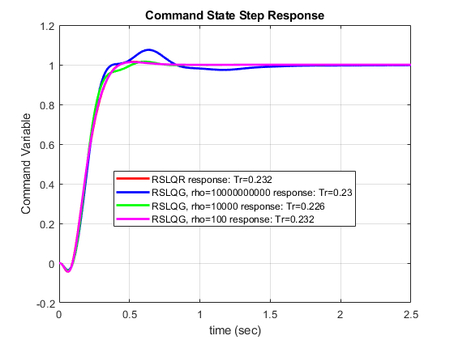
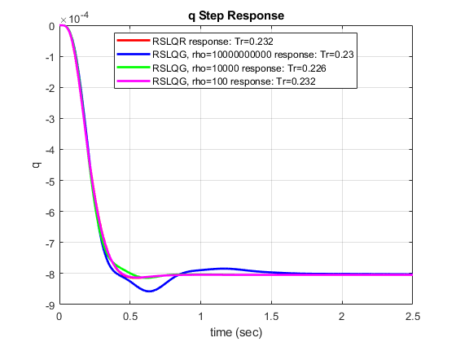
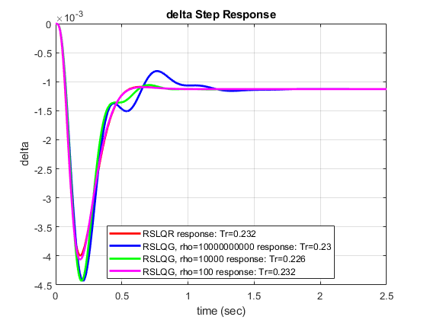
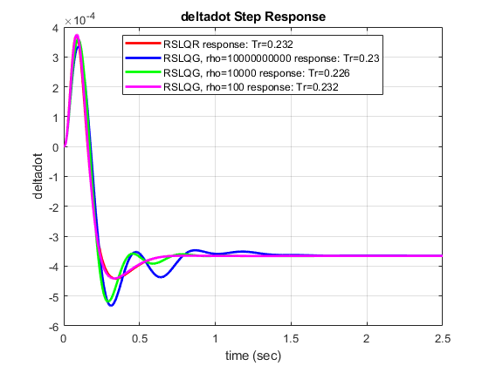
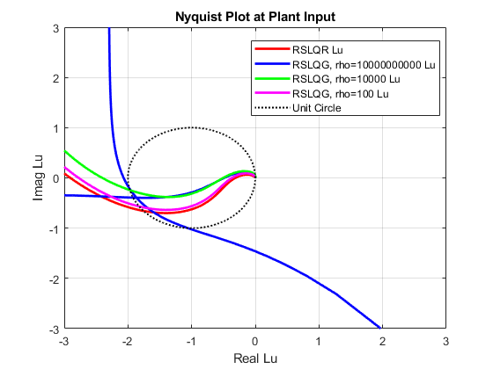
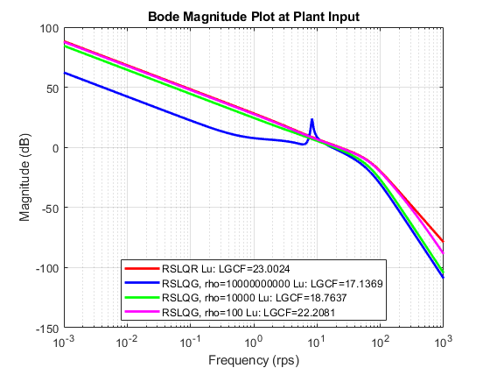
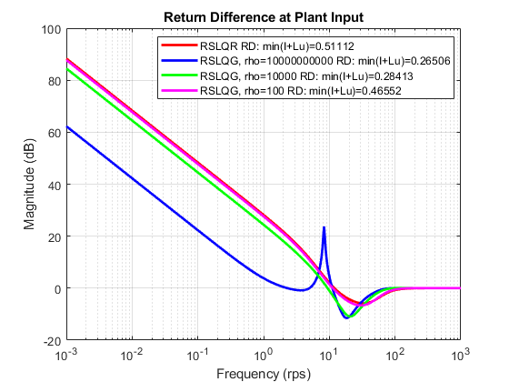
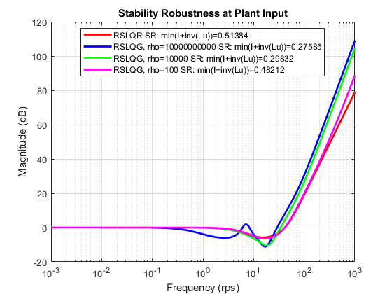
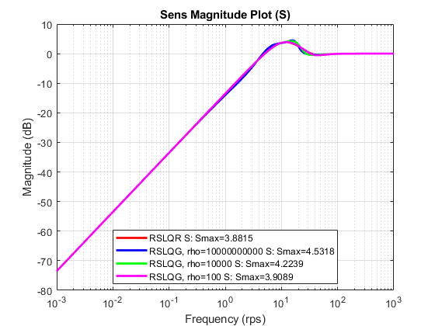
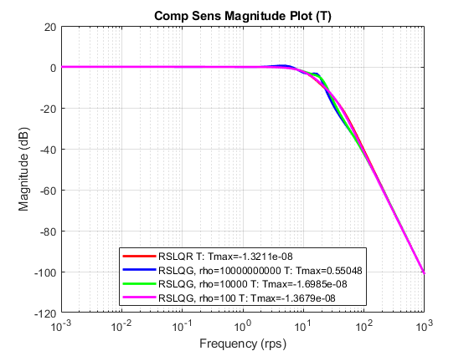
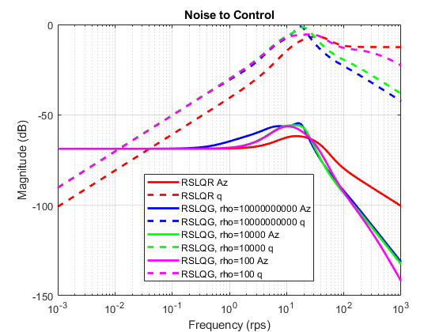
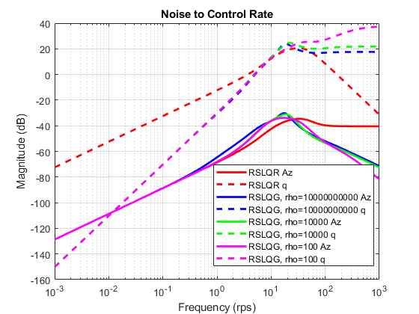

print controller info for rho = 100
Aw = RSLQG(3).Aw
C = RSLQG(3).AnalysisPlant.C
Q = RSLQG(3).Qv
R = RSLQG(3).Rv
Lrho = RSLQG(3).Lrho
Ac = RSLQG(3).Controller.Ac
Bc1 = RSLQG(3).Controller.Bc1
Bc2 = RSLQG(3).Controller.Bc2
Cc = RSLQG(3).Controller.Cc
Dc1 = RSLQG(3).Controller.Dc1
Dc2 = RSLQG(3).Controller.Dc2
Aw =
0 -1.1569e+03 0
0 -1.3046e+00 1.0000e+00
0 4.7711e+01 0
C =
-1.1569e+03 0 -1.8995e+02 0
1.0000e+00 0 0 0
0 1.0000e+00 0 0
0 0 1.0000e+00 0
0 0 0 1.0000e+00
Q =
3.6080e+02 4.0687e-01 1.9913e+02
4.0687e-01 1.8588e-03 2.2456e-01
1.9913e+02 2.2456e-01 1.0991e+02
R =
6.2500e-01 0
0 1.0000e-03
Lrho =
1.2979e+01 5.6878e+02
-4.7013e-02 1.7985e+00
9.1005e-01 3.3100e+02
Ac =
0 0 0 0
1.2979e+01 -1.1166e+01 -1.6559e+03 -6.1401e+02
-4.7013e-02 4.9056e-02 -1.8673e+00 -8.4951e-01
9.1005e-01 9.0170e-02 -2.2769e+02 -3.5596e+02
Bc1 =
1.0000e+00 0 0 0 0
0 0 5.6878e+02 0 0
0 0 1.7985e+00 0 0
0 0 3.3100e+02 0 0
Bc2 =
-1
-1
0
0
Cc =
0 -9.5410e-03 2.6270e+00 2.3809e-01
Dc1 =
0 0 0 0 0
Dc2 =
0
save('RSLQG_design.mat','RSLQG');
Published with MATLAB® R2020a

